REPORT
on the research work

"STUDY USING MOLECULAR SPECTROSCOPY METHODS
OF 40% WATER-ETHANOL SYSTEMS
AFTER CAVITATION TREATMENT
(Raman scattering spectroscopy, absorption and luminescence spectroscopy)"

Moscow 2018

Research was conducted by the scientists from the laboratory of molecular luminescence and spectroscopy (Department of General Physics) and the laboratory of laser spectroscopy of solutions of supramolecular compounds and nanostructures (Department of Quantum Electronics) from the Faculty of Physics, MV Lomonosov Moscow State University (MSU).

1. Description and marking of the samples provided; preparation of water-alcohol solutions at MSU
For reconnaissance studies in the MSU laboratories the samples of water, ethanol and 40% (v/v) alcoholic solutions (hereinafter referred to as “Samples”) were provided by Alchemy Beverages Inc. (ABI). Some of the samples were treated using Clarification Technology developed by Cavitation Technology Inc. (CTI). Characteristics and properties of a 40% aqueous ethanol are of interest to the food industry, as they are used for the production of vodka and other alcoholic beverages. The list of samples is given in the Table 1.

Table 1. The investigated samples and their name in the report.
№ | Sample | Sample marking in the Report
1. | Water | Water
2 | Processed water | WaterCav.
3 | 190ProofAlcohol | AlcoholRaw
4. | Processed190ProofAlcohol | AlcoholCav.
 | Processed 40% alcohol solution:
5. | single processed 40% alcoholsolution | Sample 40% - 1Pass
6. | double processed 40% alcohol solution | Sample 40% - 2Pass

All samples were received in glass vials in two replications. Water-alcohol solutions without treatment were prepared from the original, untreated water and alcohol (“Water” and “Alcohol Raw”) by mixing appropriate volumes; concentration is given in percentage by volume. The marking "1Pass," or "2Pass" indicates a single or double treatment in the hydrodynamic high-pressure cavitator (H.P.) of the CTI design.
In addition to the samples provided by the ABI, the water-alcohol solutions (hereinafter “Solutions”) were prepared in the MSU laboratories from water and alcohol without treatment (Water + Alcohol Raw) and processed water and alcohol (Water Cav. + Alcohol Cav.). The solutions with a 40% concentration prepared from water and alcohol without or after treatment were labeled "Sol 40%" with the used solvents in brackets. For a more detailed study of the 40% solutions in some cases cross-blends were also prepared: (Water + Alcohol Cav.) from untreated water + treated alcohol and (Water Cav. + Alcohol Raw) from treated water and unprocessed alcohol.

2. Absorption spectra of water-alcohol samples and solutions

Absorption spectra were measured using a SolarPB2201 spectrophotometer in the spectral range 200 ... 1100 nm relative to the provided water sample (Water). To reduce the measurement error of the absorption spectra of the samples provided, they were carried out in a quartz cuvette with an optical path length of 3 cm; for analysis, all spectra are reduced to optical density at 1 cm by dividing the measured values by 3.
The absorption spectra for the provided samples and prepared solutions with a concentration of 40% in the spectral range of 200 ... 1100 nm are shown in Fig. 2.1: the studied samples absorb light in the UV and near IR regions.
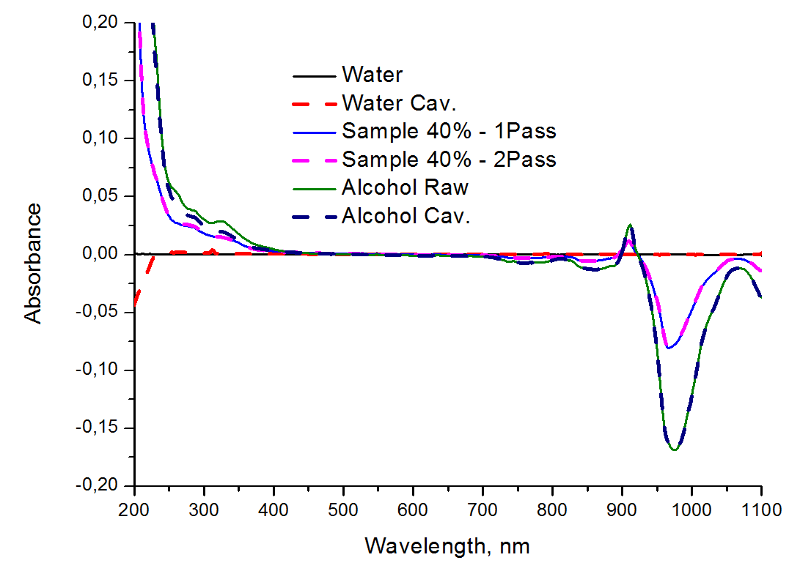
Fig.2.1. The absorption spectra of the provided samples in the spectral range 200 ... 1100 nm.

The absorption of light in the UV range is caused by electronic transitions in the containing double bonds molecules of organic impurities. The more double bonds form the conjugation chain, the higher the wavelength of the absorbed light. If a molecule has a conjugation chain consisting of seven double bonds or more, then the molecule absorbs in the visible range of the spectrum. In the studied water-alcohol samples, absorption in the visible range was practically absent.
The following figures show the UV and IR spectral regions separately on an enlarged wavelength scale: Fig.2.2-2.3 shows the absorption spectra of the provided water-alcohol samples in the UV spectral range, and Fig.2.4 shows the absorption spectra of the provided samples in the IR spectral range.

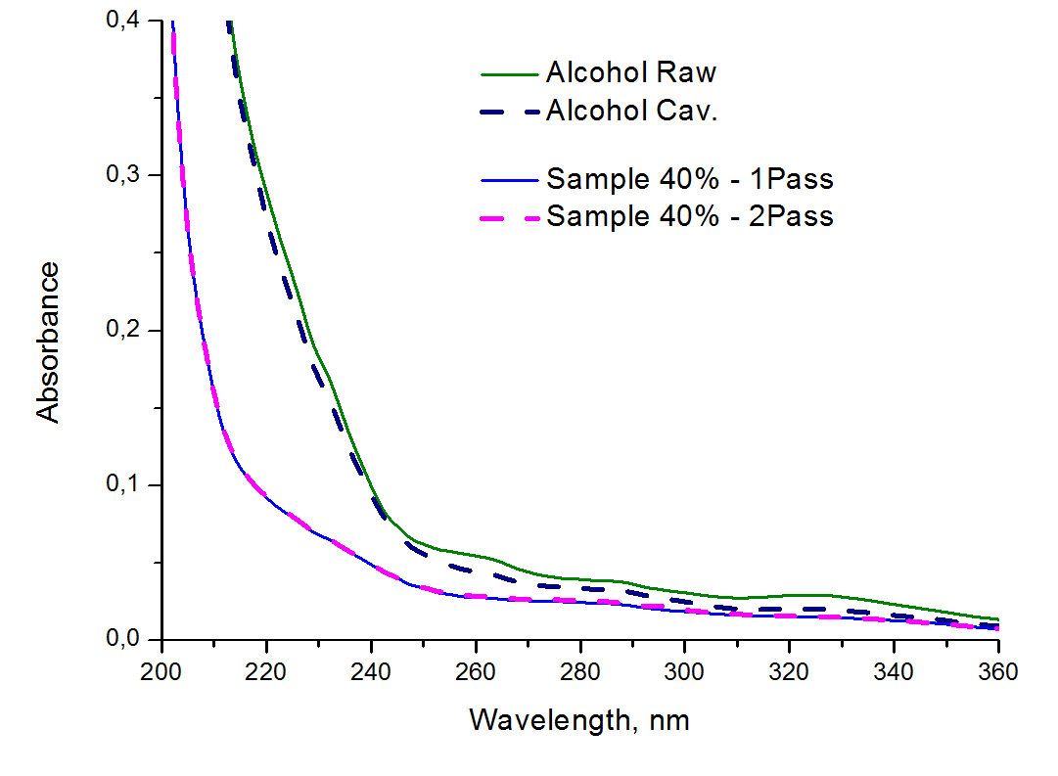
Fig.2.2. Absorption spectra in the UV spectral range of the original alcohol and alcohol after processing, as well as samples of 40% with single and double processing in the hydrodynamic high-pressure CTI cavitator.

The samples in descending order of absorbance values in the UV range are arranged in Fig.2.2 in the following order: unprocessed Alcohol Raw, processed Alcohol Cav., Samples of 40% concentration after processing (absorption spectra of samples with single and double processing almost coincide).
It can be concluded that the CTI cavitator leads to a decrease in the content of impurities absorbing light in the UV range in ethanol or alcohol solution. The spectral difference in the absorption spectra of the original and the treated alcohol is shown in Fig. 2.3; it demonstrates that the decrease in absorbance occurs mainly for the bands with peaks at 223, 260 and 325 nm. These UV bands correspond to the absorption of light by simple aromatic molecules (benzene, phenol, benzaldehyde, tyrosine, tryptophan and their derivatives).
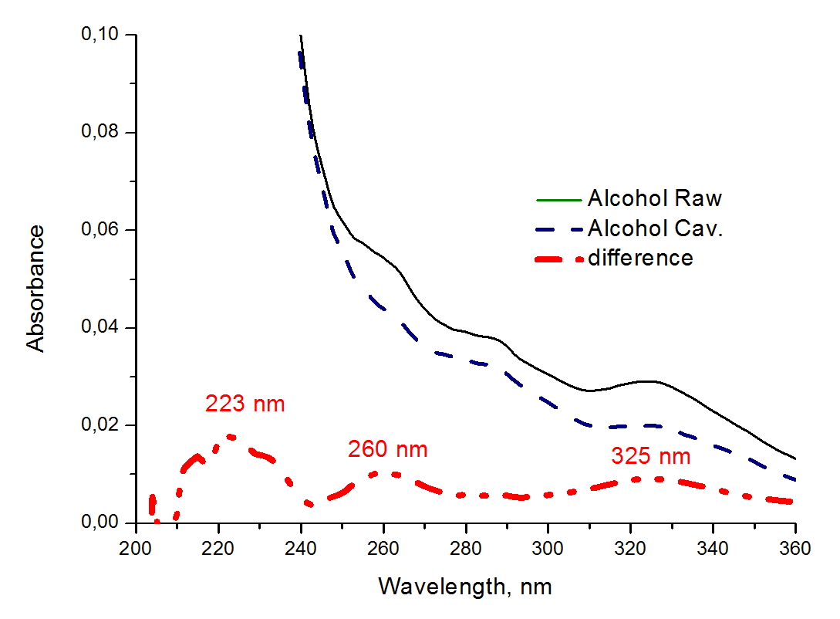
Fig.2.3. The absorption spectra in the UV spectral range of the original and processed alcohol, as well as their spectra difference.

The long-wavelength absorption region in the spectra of water-alcohol samples and solutions falls within the near-IR range (wavelengths from 840 to 1100 nm, see Fig. 2.4).
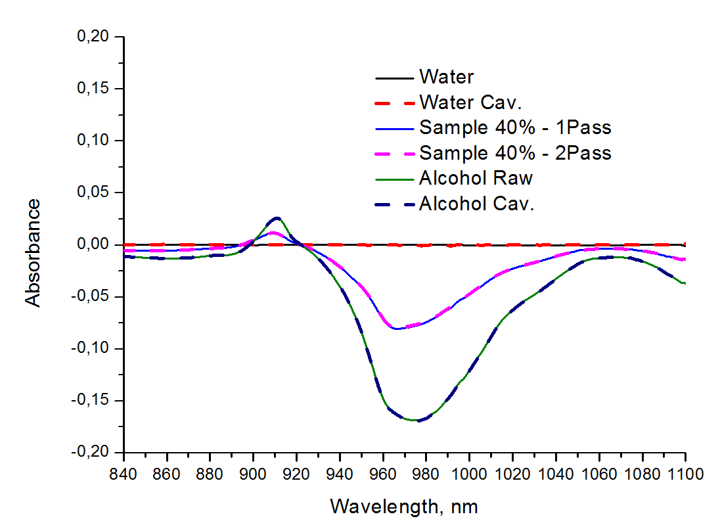
Fig.2.4. The absorption spectra of the provided samples in the IR spectral range.

These absorption bands are the difference spectra of the overtone of the vibrational bands of the CH- and OH-groups of the sample (solution) of a certain concentration and the OH-groups of water used to calibrate the zero line. In our experiment, all absorption spectra were measured with respect to provided water sample (Water). Therefore, the amplitudes of the bands with maxima at 910 nm (positive band) and 960–980 nm (negative band) depend on the alcohol concentration: the greater is the alcohol content in the solution, the higher are the amplitudes of those peaks. The amplitudes of mentioned bands can serve as a quantitative characteristic of the concentration of alcohol in the sample (solution), provided that measurements are made at a constant temperature and in respect to the same reference sample. For samples with the same alcohol concentration, the absorption spectra in the specified near-IR range are virtually equal, they do not depend on the sample processing.

The main results of the Section 2 (study of absorption spectra):
1). The studied water-alcohol systems absorb light in the UV region and in the near-IR region. Absorption in the UV range (wavelength from 200 to 360 nm) is caused by electronic transitions in the molecules of organic impurities with double bonds. Absorption bands in the IR range (wavelength from 840 to 1100 nm) represent the difference spectra of the overtone of the vibrational bands of the CH- and OH-groups of the aqueous alcohol solution under investigation and the OH-groups of water used to calibrate the zero line.
2). Cavitation treatment of samples leads to a decrease in the content of organic impurities in the alcohol and alcohol solutions that absorb light in the UV range, this is especially pronounced for compounds whose absorption peaks fall at wavelengths of 223, 260 or 325 nm. The absorption spectra of the 40%-samples with single and double processing almost coincide.
During cavitation treatment of ethanol or its aqueous solutions, the destruction or transformation of impurities may be present. For example, the break of double C = C bonds in aromatic molecules (such as derivatives of benzene, phenol, tyrosine, tryptophan) could be possible. Cavitation-stimulated effects can also break the molecular chain within larger compounds along the double bond C = C. In this case, large polyaromatic compounds can be broken into smaller fragments with shorter conjugated carbon chain.
Cavitational treatment of alcohol and water-alcohol solutions, causing the destruction of impurities, such as simple aromatic molecules, can improve the organoleptic characteristics of alcohol-based beverages used in the food industry.

3. Raman scattering spectroscopy for water-ethanol systems
Raman scattering (RS) spectra were obtained at the RS-spectrometer, which included an argon laser (LG106-M4, wavelength 488 nm, sample power 250 mW) for spectra excitation and a recording system consisting of monochromator (Acton 2500i, grating 900 lines/mm, focal length 500 mm) and CCD camera (Horiba-JobinYvon, model Syncerity). An edge filter (Semrock) was used to suppress elastic scattering. The spectra were recorded in two spectral ranges centered at 520 nm (low-frequency region of the spectrum or the region of the so-called "fingerprints") and 573 nm (region of stretching vibrations of the CH- and OH-groups), which made it possible to obtain the full Raman spectrum in the wave number range from 200 to 3800 cm⁻¹. The practical spectral resolution was 2 cm⁻¹. For each of the ranges, 10 spectra were recorded (two cycles of measurements with 5 spectra each). The signal accumulation time was 1 s (for ethanol), 2 s (for solutions with a concentration of 30-50% ethanol), 3 s (for water and solutions with a concentration of 10-30% ethanol). The processing of the spectra included a correction for the laser power and the accumulation time of the spectrum, the subtraction of the background (the minimum value), and the normalization to the area of the stretching vibrations of the CH- and OH-groups (2700-3800 cm⁻¹). The latter was done to reduce the influence on the result of the alignment of the receiving system, fluctuations in the laser power and other instrumental factors.
Typical Raman scattering spectrum of pure water is shown in Fig. 3.1.
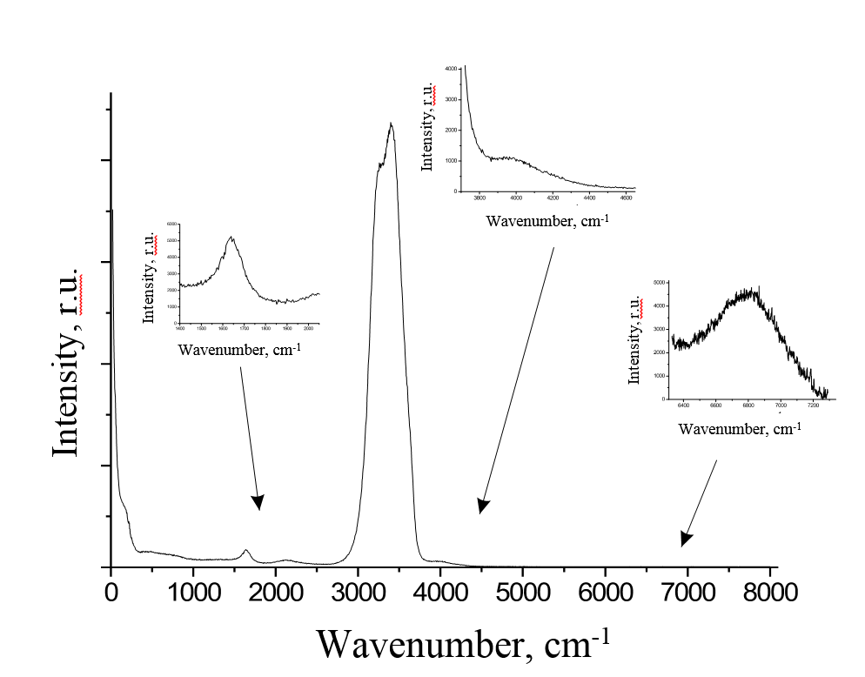
Fig. 3.1. Raman scattering spectrum of liquid water.

The main vibrational bands of the water Raman scattering spectrum have the following assignment:
- 50-200 сm⁻¹– intermolecular translational oscillations with maxima near 60 сm⁻¹and 190 сm⁻¹;
- 300-900 сm⁻¹– intermolecular librations with a maximum near 700 сm⁻¹;
- 1600-1700 сm⁻¹–HOH angle deformation vibrations with a maximum about 1645 сm⁻¹;
- 2000-2400 сm⁻¹ – associative band with a maximum of about 2150 сm⁻¹, is probably due to the intermolecular vibrational overtones and combination frequencies;
- 3000-3800 сm⁻¹ – stretching vibrations with a maximum of about 3400 сm⁻¹;
- 3900-4200 сm⁻¹ – the low-intensity band with a maximum of about 4000 cm⁻¹ is probably due to the overtones of intermolecular vibrations and the combination frequencies
- 6000-7000 сm⁻¹ – low intensity band is the overtone of the stretching band.

Typical Raman scattering spectrum of ethanol is shown in Fig. 3.2.
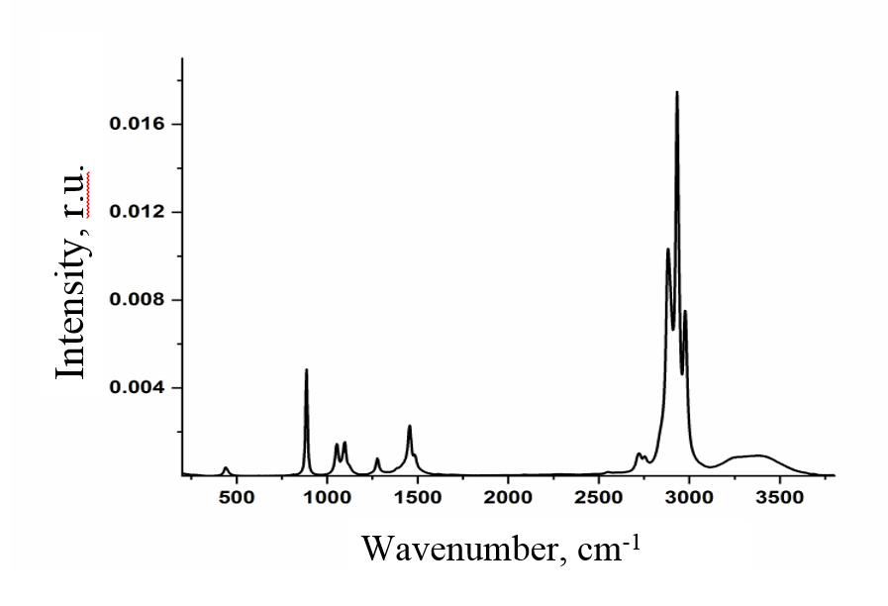
Fig. 3.2. Raman scattering spectrum of ethanol.

The main vibrational bands of the Raman scattering spectrum of ethanol (with residual water) are due to:
- 440 сm⁻¹– C—С—О deformation vibrations;
- 886 сm⁻¹ – stretchingС – Сvibrations;
- 1056 сm⁻¹ – stretching С – Оvibrations;
- 1100 – 1116 сm⁻¹ – CH₃librations;
- 1280 сm⁻¹ – torsional and fan vibrations CH₂;
- 1456 сm⁻¹ – deformation vibrations in CH₃и CH₂;
- 1486 сm⁻¹ – deformation vibrations in CH₃;
- 1630 сm⁻¹ – HOH angle deformation vibrations in residual water molecules;
- 2884 сm⁻¹ – CH- stretching symmetric vibrations in CH₂-groups;
- 2932 сm⁻¹ – CH- stretching symmetric vibrations in CH₃-groups;
- 2977-2985 сm⁻¹ – CH- stretching asymmetric vibrations in CH₃- groups;
- 2900 – 3600 сm⁻¹ – OH-stretching vibrations in water and ethanol molecules.

The experiment on the study of water-alcohol systems was carried out using the samples provided by the ABI and mentioned in the Table 1, as well as ethanol solutions of various concentrations prepared at MSU from water and ethanol (untreated and processed on the CTI cavitation unit). For control, ethanol solutions were also prepared with the same concentrations of water and ethanol from reagents of the Faculty Physics of Moscow State University. Figure 3.3 shows the obtained Raman spectra of the studied water-ethanol samples.

Fig.3.3. Raman scattering spectra: 1 - distilled water (MSU), 2 - Water, 3 – Water Cav.; 4 - ethanol (MSU), 5 – Alcohol Raw, 6 – Alcohol Cav.

To examine the molecular structure of solutions the stretching band in Raman scattering spectrum are of greatest interest: oscillations of OH-groups in the wavenumber region of 3000-3800 cm⁻¹ (due to symmetric and antisymmetric vibrations of OH-groups of water and ethanol molecules), the oscillation bands of CH-groups in the region of 2800-3000 cm⁻¹ (caused by symmetric and antisymmetric CH vibrations in the CH₃ and CH₂ groups of the ethanol molecule), the deformation vibrational bands of the CH₃ and CH₂ groups in the region of 1450 cm⁻¹, the stretching vibrations of CO (in the region of 1090 cm⁻¹), and the skeletal modes of CCO vibrations (in the region of 1050 and 880 cm⁻¹).
Fig.3.3 (curves 1-3) allows us to conclude that the cavitation treatment has almost no effect on the spectrum of water Raman scattering.
As one can see from Fig.3.3, in addition to relatively narrow Raman bands, the ethanol spectra, untreated (curve 5 in Fig.3.3) and processed (curve 6 in Fig.3.3) contain a wide band in the region of 500-3800 cm⁻¹, which is apparently caused by fluorescence of impurities. For comparison, the spectrum of highly purified ethanol from the MSU laboratory (curve 4 in Fig.3.3) contains only Raman lines without noticeable fluorescence background. The presence of a fluorescent background significantly complicates the Raman spectroscopic study. In addition to the fact that the parasitic signal distorts the shape of the spectrum, it becomes more difficult to normalize to the area of the stretching vibration bands of CH- and OH-groups. In this work, to overcome this problem the fluorescence background in the wavenumber range of 2570-3800 cm⁻¹ was replaced by a straight line to subtract it from the registered spectrum. This made it possible to distinguish the Raman bands of the stretching oscillations of the CH- and OH-groups that were used further for spectra normalization.
The Table A1 (see Appendix) presents the positions of the maxima of the ethanol Raman bands for the studied solutions. As can be seen from the Table, there are no significant changes in the positions of the vibrational bands of pure ethanol before and after treatment of the solutions (Alcohol Raw and Alcohol Cav.). All variations in position maximum do not exceed 2 cm⁻¹, which is close to the spectral resolution of the spectrometer.
Since the main mechanism providing intermolecular bonding in water and ethanol-water solutions is hydrogen bonding, the most informative part of the vibrational spectrum is the region of stretching vibrations of OH-groups 3000-3800 cm⁻¹. The maximum position and bandshape of the stretching vibrations, as was established by a number of researchers, are very sensitive to tiny changes in hydrogen bonding in aqueous solutions. As numerical parameters describing the position and shape of the stretching band of CH- and OH-groups it is convenient to use the wavenumber of the center of mass (gravity center) and the value of the parameter χ₂₁, equal to the intensities ratio of the high-frequency to low-frequency regions of the stretching band in Raman spectrum. Figure 3.4illustrates determination of those parameters.

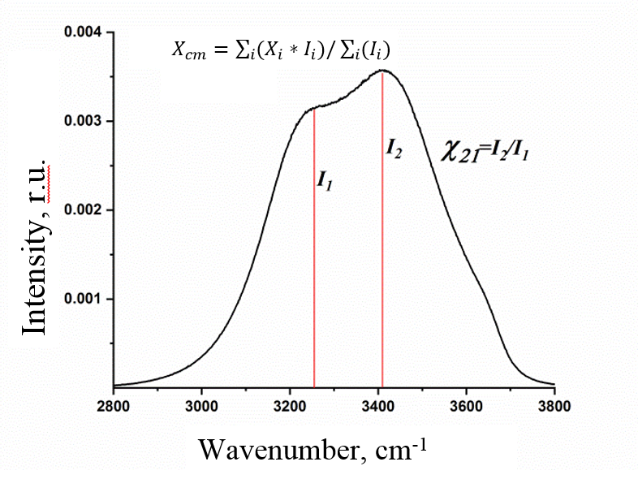
Fig.3.4. Illustration of the calculation of the parameter χ₂₁ and the position of the center of mass using the stretching band of water Raman spectrum as an example.

Calculating the parameter χ₂₁ we used the intensities at the maximum of the spectrum and at the point with a wavenumber of 3261 cm⁻¹.
The position of the center of mass of the band was calculated by the formula $X_{cm}=\sum_{i}{(X_{i}*I_{i})/\sum_{i}{{(I}_{i}}})$, whereX_{cm} – wavenumber (in cm⁻¹) of the center of mass, X_{i}– wavenumber of the i-th spectral channel, I_{i} - intensity in the i -th spectral channel.
The position of the center of mass for wide spectral bands is more convenient to use than, for example, the position of the maximum of the spectrum, since this parameter is more resistant to the influence of instrumental noise. The parameter χ₂₁ characterizes the shape of the band (its deformation under the influence of certain factors). In the simplest model, when the shape of the stretching band of the OH-groups is described by the contributions of OH-groups with weak hydrogen bonds (high-frequency spectral region) and strong (low-frequency region) hydrogen bonds, this parameter characterizes the ratio between the numbers of OH-groups with strong and weak H-bonds. An increase in the value of this parameter indicates a weakening of the hydrogen bonding in the solution.
As follows from the results presented in Tables A2 and A6 (see Appendix), the positions of the vibrational bands in 40% water-ethanol solutions, both in provided samples and prepared at the MSU laboratory from treated and untreated water and alcohol in different combinations, remained almost unaltered.
However, from the Tables A4 and A7 (Appendix) it follows that the position of the OH-stretching band and the parameter χ₂₁ for the treated water-ethanol solutions of concentration 40% (ABI Sample 40%) differ from that for untreated 40% solutions. This is valid also for the 40% solutions prepared at MSU from treated water and ethanol (Water Cav.+Alcohol Cav.) in comparison to solutions prepared at MSU from untreated solvents.
From the Tables A5 and A8, it follows that the ratio of the integral intensities of the stretching bands of the CH- and OH-groups in water-ethanol solutions is noticeably greater for the samples provided by the ABI that have been processed after the preparation than for solutions prepared at MSU from treated water and ethanol.
The following figures show the Raman spectra for the studied samples and water-alcohol solutions in the region of stretching vibrations of the CH- and OH-groups after subtracting the fluorescent background.

Fig.3.5. Stretching band in Raman spectra for water samples: 1 - Water; 2 – Water Cav.

Fig.3.6. CH- and OH-stretching bands in Raman spectra for ethanol samples: 1 – Alcohol Raw; 2 – Alcohol Cav. Fluorescent background subtracted.
Fig.3.7. CH- and OH-stretching bands in Raman spectra for the ABI 40% samples: 1 – Sample 40% - 1Pass., 2 - Sample 40% - 2Pass. Fluorescent background subtracted.

Fig.3.8. CH- and OH-stretching bands in Raman spectra for the 40% ethanol solutions: 1 – Solution 40% (Water + Alcohol), 2 – Solution 40% (Water Cav. + Alcohol Cav.), 3 – Sample 40% 2Pass. Fluorescent background subtracted.

In addition to the above described measurements, the experiment was conducted in which water-ethanol solutions were prepared with ethanol concentrations of 40% and 60% in all possible combinations, treated and untreated water and ethanol (untreated water + untreated ethanol, untreated water + treated ethanol, treated water + untreated ethanol, treated water + treated ethanol). The obtained spectra are presented in Fig.3.13 and Fig.3.14. The Tables A6-8 (Appendix) present the characteristics of the spectra obtained.

Fig.3.9. CH- and OH-stretching bands in Raman spectra for the 40% ethanol solutions prepared from treated and untreated solvents in various combinations: 1 – Solution 40% (Water+Alcohol Raw), 2 – Solution 40% (Water+Alcohol Cav.), 3 – Solution 40% (Water Cav.+Alcohol Raw), 4 – Solution 40% (Water Cav.+Alcohol Cav.). Fluorescent background subtracted.
Fig.3.10. CH- and OH-stretching bands in Raman spectra for the 60% ethanol solutions prepared from treated and untreated solvents in various combinations: 1 – Solution 60% (Water+Alcohol Raw), 2 – Solution 60% (Water+Alcohol Cav.), 3 – Solution 60% (Water Cav.+Alcohol Raw), 4 – Solution 60% (Water Cav.+Alcohol Cav.). Fluorescent background subtracted.

The main results of the Section 3 (Raman scattering spectroscopy):
1). The positions of low-frequency Raman lines of ethanol molecules (vibrations of CH, CCO, CO bonds) are insensitive to the cavitation treatment of ethanol.
2). Since the main mechanism providing intermolecular bonding in water-ethanol systems is hydrogen bonding, the most informative part of the vibrational spectrum is the region of stretching vibrations of OH-groups from 3000 to 3800 cm⁻¹. Above the concentration of ethanol in solution higher 30%, the position of the stretching band and its shape for the treated solutions differ from those for the bands of untreated solutions: the OH-stretching band is slightly shifted to the high-frequency region, and the parameter χ₂₁ increases compared to the same characteristics for the bands of the unprocessed solutions. This means that after cavitation treatment in solutions the number of OH-groups with weak hydrogen bonding is greater than in untreated solutions. Fig.3.7-3.10 illustrates the findings.
3). The ratio of the integral intensities of the stretching bands of the CH- and OH-groups in water-ethanol solutions is significantly greater for the ABI solutions that have been processed with cavitator after preparation than for the solutions prepared at MSU from previously treated water and ethanol.
4) In the measurements, the fluorescent background interferes with Raman scattering bands, and therefore makes more difficult the interpretation of the shape of the stretching OH-band in Raman spectra.
In previous studies (J. Agric. Food Chem. DOI: 10.1021 / jf100609c.), it was found that in aqueous solutions of ethanol the existence of various molecular structures like water clusters, clusters of ethanol molecules or heterogeneous water-ethanol associates (hydrated ethanol) is possible. At high alcohol content (∼40 vol %) clusters from ethanol molecules appear, as revealed by the emergence of the ethanol line in 400 MHz NMR. These ethanol clusters undoubtedly stimulate the palate differently from either water clusters or the clathrate-like water-ethanol structures (hydrated ethanol). Even in the absence of “taste” in the traditional sense, vodka drinkers could express preference for a particular structure. It is a possible that trace impurities compound influence Hydrogen-bonding and thus alter the component distribution.

4. Fluorescence of samples of water, alcohol samples and water-ethanol solutions
To record the fluorescence spectra of the samples and the prepared aqueous-alcoholic solutions, a Solar CM2203 fluorimeter with a xenon pulsed lamp was used as an excitation source. The optical layout of the instrument is shown in Fig. 4.1.
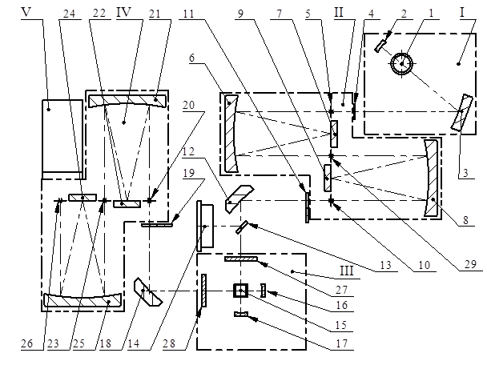
Fig. 4.1. The optical layout of the Solar CM2203 luminescence spectrometer. I – excitation system; II - excitation monochromator; III - cuvette compartment; IV - registration monochromator; V - photodetector. A detailed description is given in the text.

The excitation system I includes radiation source 1 (XBO 150W/1 xenon short arc lamp with an almost continuous emission spectrum in the wavelength range of 220–1000 nm), reflector 2 and ellipsoid focusing mirror 3. Radiation from the lamp 1 is focused by the mirror 3 on the entrance slit 5 of the excitation monochromator II. Using the collimator lens 6, the light, in the form of a parallel beam, is directed onto the diffraction grating 7. The rays diffracted from the grating 7 are focused by the lens 6 onto the intermediate slit 29. An intermediate slit separates the spectral range of wavelengths in the second monochromator, where the second diffraction is performed. Dispersions of both parts of the double monochromator are added up and a certain spectral range of wavelengths, depending on the angle of rotation of the gratings 7 and 9, is allocated through the output slit 10. The toroidal mirror 12 focuses the radiation transmitted by the monochromator II to the center of the cuvette 15 with the sample under study. The luminescence is collected by a toroidal mirror 18 and is focused on the entrance slit 20 of the registration monochromator IV. Reflector 16 and 17 can increase the intensity of the luminescence signal in 2.5 - 3 times. After exiting the registration monochromator IV, the analyzed luminescence emission is recorded by a photomultiplier.
Samples and water-alcohol solutions for spectra measurements were placed in a standard quartz cell for fluorimetry. Fluorescence was excited by a set of wavelengths ranged from 230 to 405 nm in order to identify differences in the samples provided.
Fluorescence spectra of the provided ABI ethanol sample (Alcohol Raw) and ethanol after treatment (Alcohol Cav.) are shown in Fig. 4.2 when excited by different wavelengths indicated on the graph. Narrow lines correspond to the Raman scattering (RS) band of the solvent, and the wider band after the RS line corresponds to the fluorescence emission spectrum.
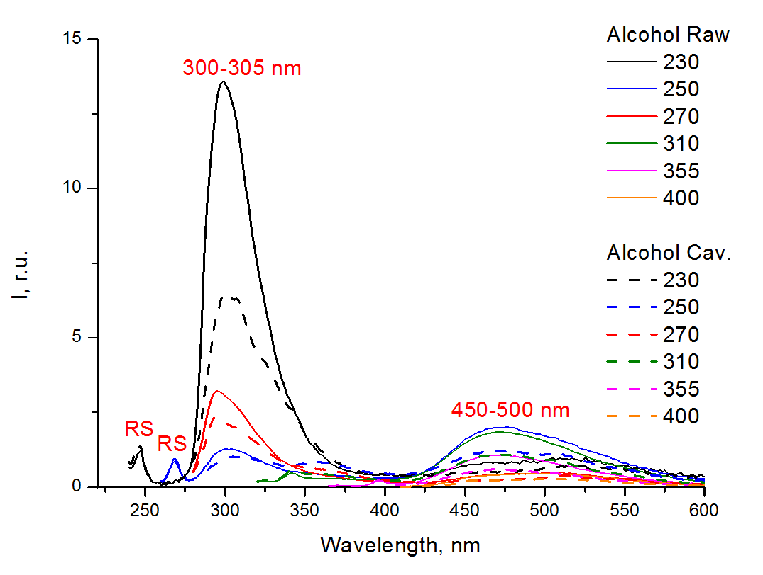
Fig. 4.2. Fluorescence spectra of the ABI alcohol (Alcohol Raw) and alcohol after processing (Alcohol Cav.) with different excitation wavelengths (given on the right). RS – Raman scattering band.
The main fluorescence band of organic impurities in ethanol has a maximum at 300–305 nm when excited by wavelengths shorter 270 nm. These can be benzene, simple phenols, amino acids tyrosine and tryptophan, benzaldehyde, or other organic compounds with isolated benzene nuclei. The second fluorescence band is located in the visible region within 450-500 nm, this luminescence may be due to aromatic compounds with condensed benzene nuclei.
All samples provided, regardless of the alcohol concentration or the type of treatment, were fluorescent when excited by the UV light. Fig. 4.4-4.5 show the fluorescence spectra of the samples excited with a wavelength of 230 nm, as best illustrating the fluorescence, but similar results were obtained for other wavelengths of excitation within the UV range. This is consistent with the results of the Section 2 obtained by measuring the absorption spectra of the samples.
As can be seen from Fig. 4.2, cavitation treatment of ethanol reduces by 1.5-2 times the content of fluorescent impurities, both monoaromatic and polyaromatic. Moreover, for solutions prepared from treated alcohol and water, this tendency (a decrease in the amount of fluorescent impurities) is retained. This is illustrated by the Fig. 4.3 with fluorescence spectra of water-alcohol solutions of 40% concentration prepared from untreated water and alcohol Sol 40% (Water+Alcohol Raw), as well as water and alcohol after treatment Sol 40% (Water Cav.+Alcohol Cav.).
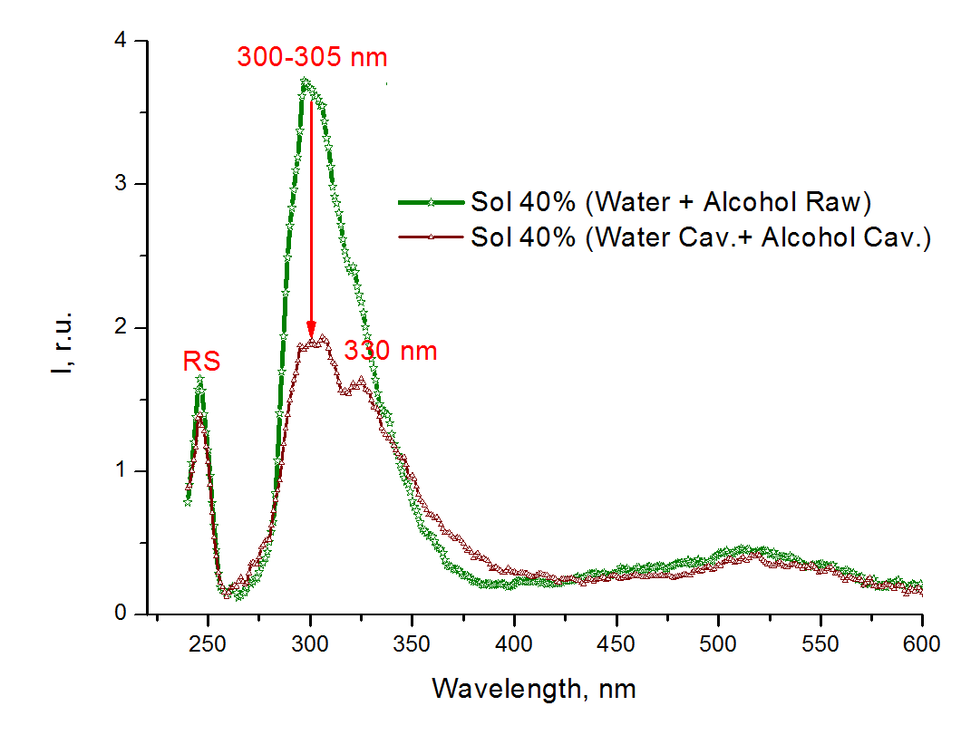
Fig. 4.3. Fluorescence spectra excited at 230 nm for 40% ethanol solutions prepared from water and alcohol without treatment Sol 40% (Water+Alcohol Raw) and after solvents processing Sol 40% (Water Cav.+Alcohol Cav.). RS – Raman scattering band.

After cavitation treatment of pure alcohol or 40% solution, the amount of impurities emitting at 300-305 nm decreases most of all. However the amount of impurities with fluorescence at 330-340 nm is slightly increases, especially after processing of the already prepared 40% solution (see Fig. 4-4-4.7), which may indicate the transition of some compounds to the oxidized (more polar) form.
The least amount of fluorescent impurities was in the solution prepared from treated water and alcohol - even less than in the sample Sample 40% 2Pass (see Fig. 4.4).

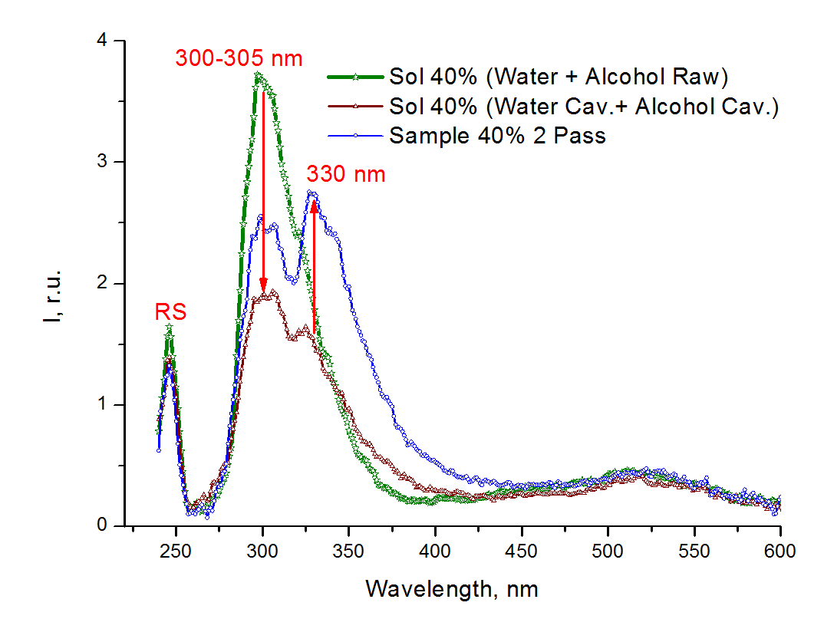
Fig. 4.4. Fluorescence spectra excited at 230 nm: ABI 40% alcohol sample with double treatment Sample 40% 2Pass; 40% solutions prepared from water and alcohol without treatment Sol 40% (Water+Alcohol Raw) and processed solvents Sol 40% (Water Cav.+Alcohol Cav.). RS – Raman scattering band.
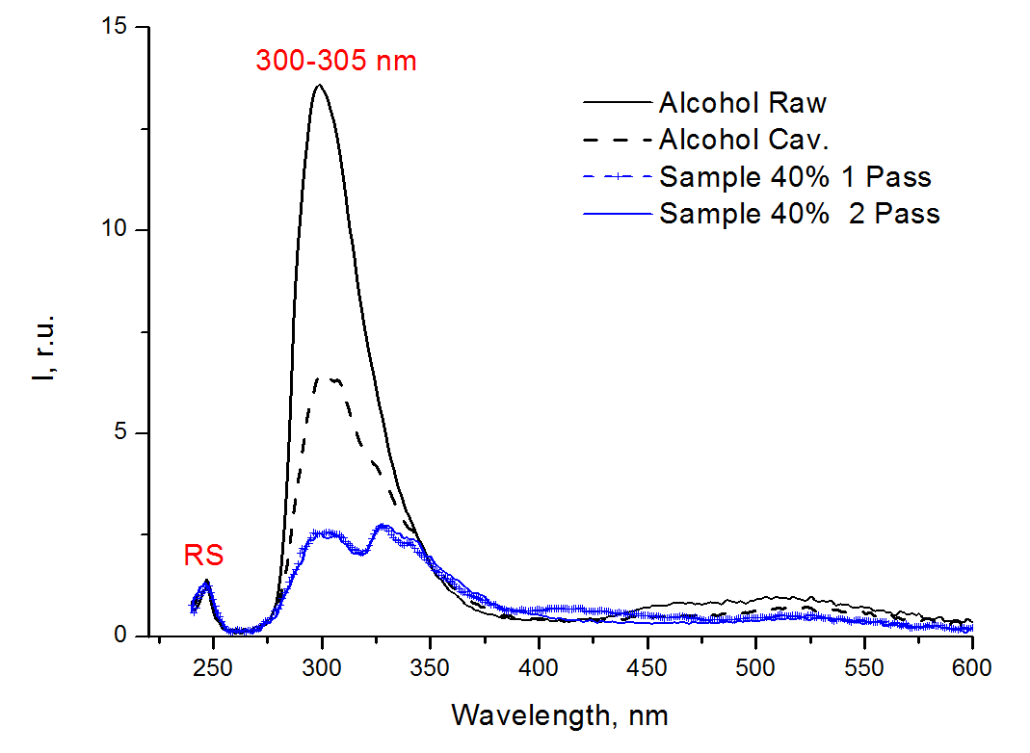
Fig. 4.5. Fluorescence spectra of the ABI water-alcohol samples upon excitation with a wavelength of 230 nm. RS – Raman scattering band.

Fig. 4.6 shows the fluorescence spectra of the sample 40% Alcohol Cav. 2Pass, with the lowest fluorescence intensity among the samples provided. Based on the data of absorption spectroscopy (see Section 2), it can be argued that this sample contained the smallest amount of organic impurities among the 40% ABI alcohol samples provided. The main fluorescence peaks of this sample are located at 300 nm, 330 nm and a wide band is suited in the visible region of 450-550 nm.
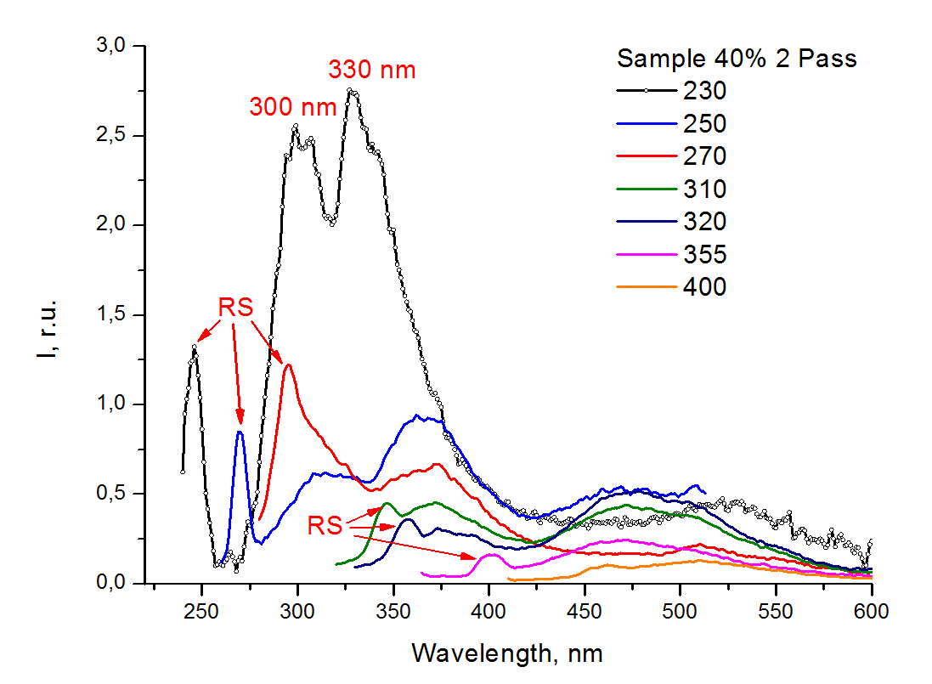
Fig. 4.6. Fluorescence spectra of the treated Sample 40% 2Pass with different excitation wavelengths (given on the right). RS – Raman scattering band.

Fig. 4.7 shows the fluorescence spectra excited at 230 nm of the 40% ABI samples with single and double processing in a high-pressure hydrodynamic cavitator (H.P.). Fluorescence spectra of samples with single and double processing differ slightly, mainly in the spectral region of 400-450 nm, the intensity of which decreases after second stage of treatment processing. Thus, when applying a doubled cavitation treatment in a high-pressure hydrodynamic cavitator (H.P.), impurities emitting visible fluorescence at 400-450 nm are partially removed.

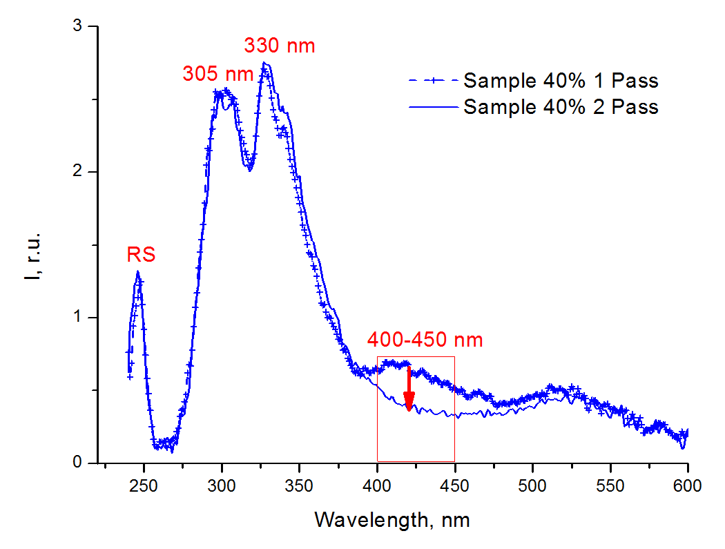
Fig. 4.7. Fluorescence spectra excited at 230 nm for the samples with single and double processing in a high-pressure hydrodynamic cavitator (H.P.). RS – Raman scattering band.

The main results of the Section 4 (fluorescence study of water-alcohol solutions):
1). The original untreated water turned out to be sufficiently pure, without impurities of organic matter giving fluorescence.
2). The ABI alcohol (both processed and untreated) contains fluorescent impurities, but in different concentrations. The main fluorescence band of impurities in ethanol has a maximum at 300-305 nm; these can be attributed as emission of simple phenols, amino acid tyrosine, benzaldehyde, and other organic compounds with isolated benzene nuclei. The second fluorescence band is located in the visible region of 450-500 nm. These may be due to polyaromatic compounds with condensed benzene cores.
The least amount of fluorescent impurities was in the solution prepared from treated water and alcohol, even less than in the double treated Sample 40% 2Pass.
Cavitational treatment of alcohol leads to a significant decrease of the content of organic impurities, fluorescing both in the UV and visible ranges, in the treated alcohol as well as in alcohol solutions prepared from it.
3) During doubled cavitation treatment in a high-pressure hydrodynamic cavitator (H.P.) additionally impurities were removed with a fluorescence maximum of 400-450 nm.
4) The mechanism of action of cavitation treatment on the organic impurities in aqueous alcoholic systems may involve breaking of the double bonds in the carbon chain and shortening of the conjugated electronic system. This therefore leads to a decrease in the absorption of light in the optical UV range and a decrease in fluorescence emission (both in the UV and in the visible range) excited by wavelengths in the UV range.
Cavitation ethanol treatment reduces significantly, in 1.5-2 times, the content of impurities such as mono- and polyaromatic compounds (derivatives of benzene, phenol, tyrosine, tryptophan, benzaldehyde, and other organic compounds). A significant reduction of impurities in alcohol and alcohol solutions after cavitation treatment can improve the organoleptic characteristics of alcohol-based beverages used in the food industry.

5. The main results and conclusions of the entire Report:
As a result of the conducted spectroscopic research performed on the provided samples and prepared water-ethanol solutions with different alcohol content and varying types of cavitation treatment, the following conclusions were made:
1). The cavitation treatment leads to a reduction of impurities in pure ethanol as well as in alcoholic solution prepared from treated ethanol, which absorb light in the UV range and emit fluorescence in the UV and visible range. The doubled hydrodynamic cavitation treatment in the high pressure cavitator (H.P.) also removes impurities with a maximum of fluorescence at 400-450 nm.
The mechanism of action of cavitation treatment on the organic impurities in aqueous alcoholic systems may involve breaking of the double bonds in the carbon chain and shortening of the conjugated electronic system. This therefore leads to a decrease in the absorption of light in the optical UV range and a decrease in fluorescence emission (both in the UV and in the visible range) excited by wavelengths in the UV range.
2). The wavelength of maximum and the bandshape of the stretching band in the Raman scattering spectrumfor the 40% (v/v) alcohol solution treated by cavitation differ from that for the unprocessed alcohol solution of the same ethanol concentration: the OH-stretching band shifts towards the high-frequency wavenumber region, and the parameter χ₂₁ (the intensities ratio at high-frequency to low-frequency region). This means that after caviatation processing in the 40% alcohol solution, the number of OH-groups with weak hydrogen bonds is greater than in the untreated sample. The ratio of the integral intensities of the stretching bands of the CH- and OH-groups in water-ethanol solutions is significantly greater for processed ABI solutions that have been processed with cavitator after preparation than for the solutions prepared at MSU from previously treated water and ethanol.
In aqueous solutions of ethanol, the existence of various molecular structures like water clusters, clusters of ethanol molecules or heterogeneous water-ethanol associates (hydrated ethanol) is possible. At high alcohol content (~40 vol %) ethanol clusters appear. These ethanol clusters undoubtedly stimulate the palate differently from either water clusters or the clathrate-like water-ethanol structures. Even in the absence of “taste” in the traditional sense, vodka drinkers could express preference for a particular structure. It is possible that trace impurity compounds influence Hydrogen-bonding and thus alter the component distribution.
3) Cavitation ethanol treatment reduces significantly, by 1.5-2 times, the content of impurities such as mono-and polyaromatic compounds (derivatives of benzene, phenol, tyrosine, tryptophan, benzaldehyde, and other organic compounds). A significant reduction of impurities in alcohol and alcohol solutions after cavitation treatment can improve the organoleptic characteristics of alcohol-based beverages used in the food industry.

Investigators:
Associate Professor,
Candidate of Physical and Mathematical Sciences (PhD in Physico-mathematical sciences)
______________________________ Svetlana Patsaeva;
Leading Researcher,
Candidate of Physical and Mathematical Sciences (PhD in Physico-mathematical sciences)
______________________________ Tatiana Dolenko;
Senior Researcher,
Candidate of Physical and Mathematical Sciences (PhD in Physico-mathematical sciences)
______________________________ Sergey Burikov;
Junior Researcher
______________________________ Daria Khundzhua.

